Oporto Museums

Serralves Foundation
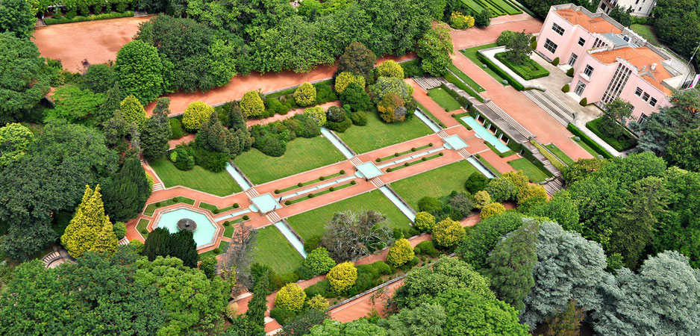

The Serralves Foundation is one of the most outstanding cultural institutions of the city of Porto. Besides exhibiting an interesting artistic collection constantly renewed, it has beautiful gardens of romantic style to relax.
This foundation consists of two buildings:
- The Serralves Museum, designed by Siza Vieira, a contemporary architect of world fame, where there are collections of Contemporary Art, both Portuguese and international.
- The House of Serralves, which was the former home of the Counts of Vizela and where temporary exhibitions are held.
Annually, on the first weekend of June, Serralves celebrates its birthday by the name of Serralves in Festa and the venue is open to the public for 72 hours non-stop, with concerts, parties, exhibitions and children's entertainment. To not lose!
Address:
Rua João de Castro 210
Schedule:
October to March – 10h to 18h
April to September – 10h to 19h

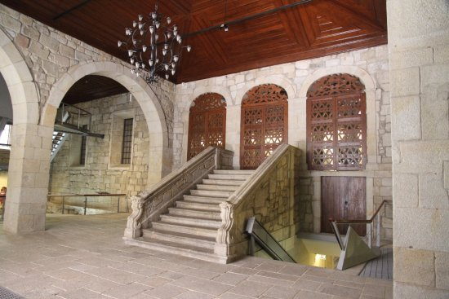
Infante House

Casa do Infante, also known as Alfândega Velha, occupies the building that was once the Customs House of Porto. This building is located in the Ribeira and dates from 1300. Its creation began when at the time King Dom Afonso IV began to fear that the Portuguese crown was to lose some of the riches that arrived from the first maritime explorations.
This building has undergone many transformations over time, but both the façade and some of the rooms inside it remain intact. In the visit you can know, by videos and maps, all these transformations and have access to the oldest maps of the city of Porto.
Here is also the Historical Archive of Porto.
The name "Casa do Infante" is due to the fact that it was there that Infante Dom Henrique, the most important figure of the Age of Discovery was born, who took Portugal to the African coast, relying on himself the naval power of the kingdom that would lead them to two centuries of discoveries and achievements.
Prices:
Tuesday to Friday: 9:30 to 13:00 / 14:00 to 17:30 – 2,20€
Saturday and Sunday: 9:30 to 13:00 / 14:00 to 17:30 - Free
Address:
Rua da Alfândega

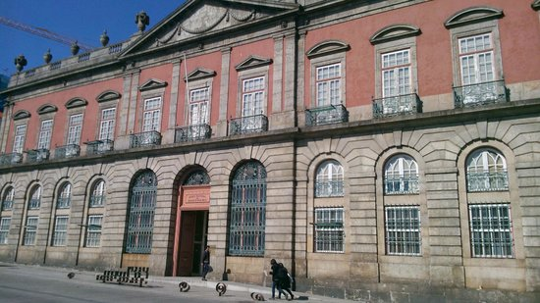
Soares dos Reis National Museum

It is located in the Palace of the Carrancas and is a building of neoclassical architecture of the end of the century. XVIII, in which lived the royal family of D. Pedro V, when they visited the north of the country.
Its collections cover pieces dating back to the 19th century. XVII until the beginning of the century. XX. In addition to having a room reserved for temporary exhibitions, the remaining exhibitions have been divided for centuries.
For those who are looking for good works of art in museums, the Soares dos Reis National Museum also has a well selected collection of paintings and sculptures in two of its rooms, highlighting the work of António Soares dos Reis, XIX for whom, deservedly, the museum has this name.
Prices:
Normal ticket - € 5
Free for children under 12 years.
Address:
Rua D. Manuel II
Schedule:
Tuesday to Sunday – 10h to 18h

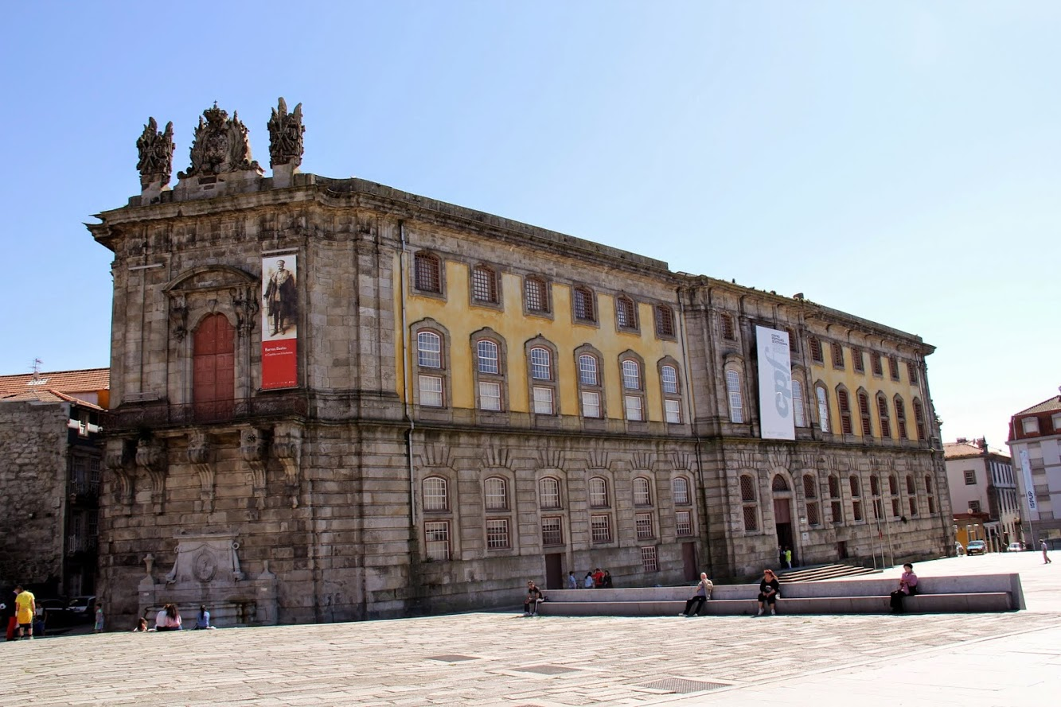
Photography Museum of Porto

The site where the Museum of Photography of Porto currently stands was used as a prison since its construction in 1796 by the architect Eugénio dos Santos (who also built part of Lisbon after the 1755 earthquake).
The building itself is a very interesting place to visit, where by its own architecture and known history, one can know the place where the residents of the city were constantly watched.
The Porto Photography Museum was created in 1997 to protect and promote the photographic heritage of the city and currently, among its cells is also the Portuguese Center of Photography, with a collection of photos from different historical periods of Portugal.
Prices:
Free
Address:
Campo Mártires da Pátria
Schedule:
Tuesday to Friday - 10h to 18h
Saturdays and Sundays – 15h to 19h

Romantic Museum
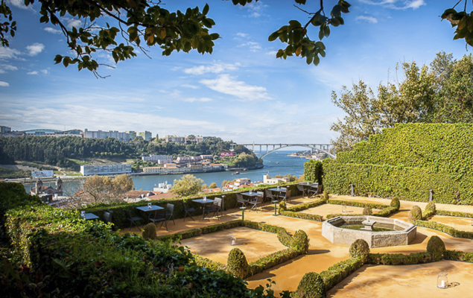
The Romantic Museum is located in the '' Quinta da Maceirinha '', next to the Crystal Palace. It was on this farm that King Carlos Alberto of Piemonte and Sardeña lived during the last years of his life and faithfully reproduces the style of life of the Portuguese bourgeoisie of the 16th century. XIX.
The bourgeoisie of the 19th century was of great importance in the country's progress, creating many of the most important industries of the time.
The museum has furniture, picturesque works and various objects from this period, faithfully reconstituting the decoration of the house, during the period in which King Carlos Alberto inhabited it.
We recommend your visit not only to those who are curious about the private life of this time, but also for the incredible views over the river Douro.
Prices:
Tuesday to Friday - € 2.20
Weekend - Free
Address:
Rua de Entre Quintas 220
Schedule:
Tuesday to Saturday - 10:00h to 17:30h
Sundays – 10h to 12:30h
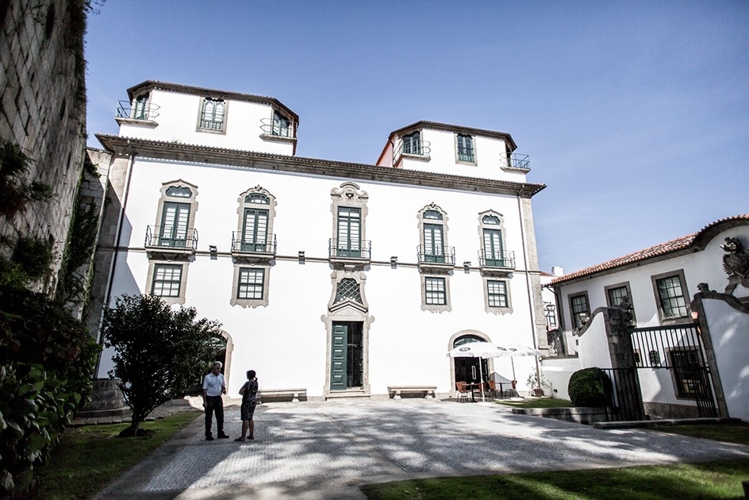
Guerra Junqueiro House Museum

The Casa Museo Guerra Junqueiro was a mansion built between 1730 and 1746, where the clergyman of the Cathedral lived at that time.
In fact, the author Abilio Guerra Junqueiro (1850 - 1923) never lived in this house, but after this house was inherited his daughter decided to put all the furniture and collections of art and silver of the writer and romantic poet so that his memory could last in time.
It is a very interesting place not only for those who know Portuguese literature (or interested in knowing it), but also for those who appreciate the art and life of the romantic era in the 19th century. XIX.
It is near the Cathedral and can be part of a deep visit to this area.
Prices:
Tuesday to Friday - € 2.20
Weekend - Free
Address:
Rua de Dom Hugo 32
Schedule:
Tuesday to Saturday - 10:00h to 5:30h
Sundays – 10:00 to 12:30h

World of Discoveries
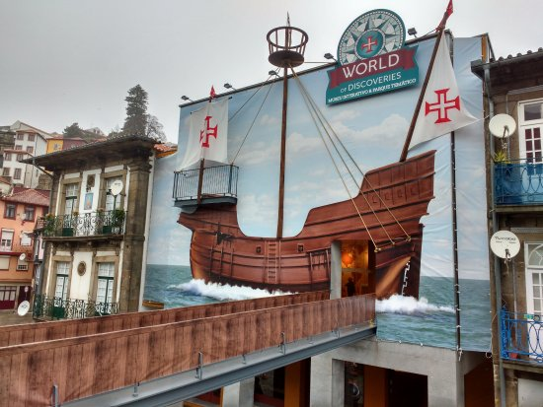

World of Discoveries is in the area of Miragaia, next to the Douro River.
This museum is inspired by the history of the Portuguese people, the trips and the achievements they have made throughout the world, making it an excellent place to visit the city of Porto with children.
This museum is made up of several interactive rooms:
The first room of the museum is dedicated to the ships, representing the evolution of Portuguese ships, from the rowboat to the caravels and ships, as well as the instruments necessary for the maritime navigation of that time.
In the second room there is a simulation of what life would be like on board these vessels and also a recreation of the place where the cargo was transported and where the crew cooked and stayed overnight.

Finally, there is a guided boat tour inside the facilities, where visitors use a channel with various scenarios (always with audio guides in several languages), and faithfully learn the whole history of the Portuguese discoveries, from Africa, Indica, China, Timor, Japan, Macau and Brazil. This course is full of visual effects, creating an atmosphere typical of every corner of the world that is visited. It's an exciting experience, especially when you cross the '' Storm End ''.
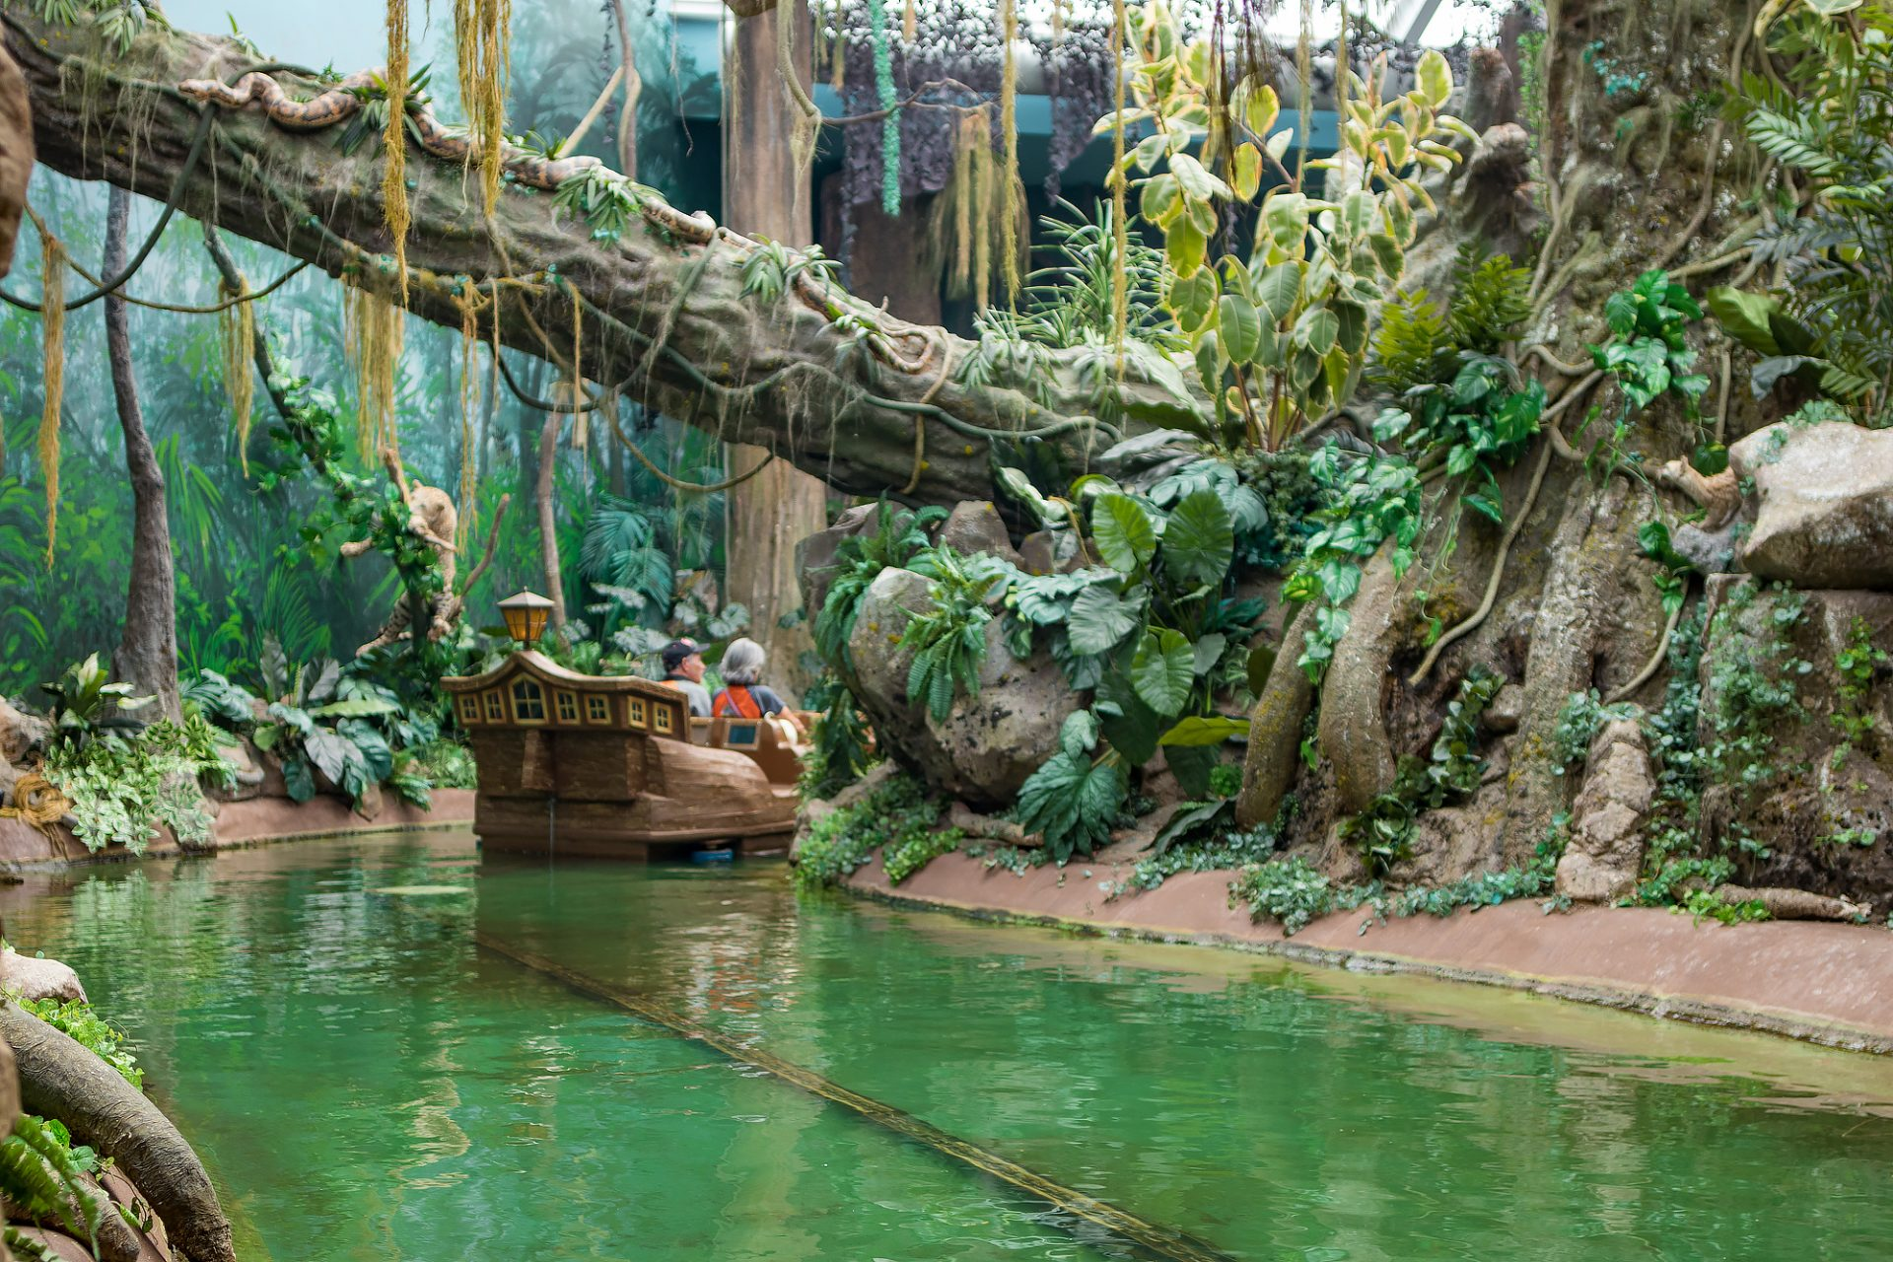

The whole museum is prepared to receive visitors with special needs. It is adapted for visitors with special educational needs, of the sensorial or cognitive type.
Prices:
Adults - € 14 or € 11 (if purchased online)
Children (4 to 12 years old) - 8 € or 6,8 € (online)
Address:
Rua de Miragaia, 106
Schedule:
Monday to Friday - 10am to 6pm
Weekends and holidays - 10am to 7pm

