Port Wine Cellars
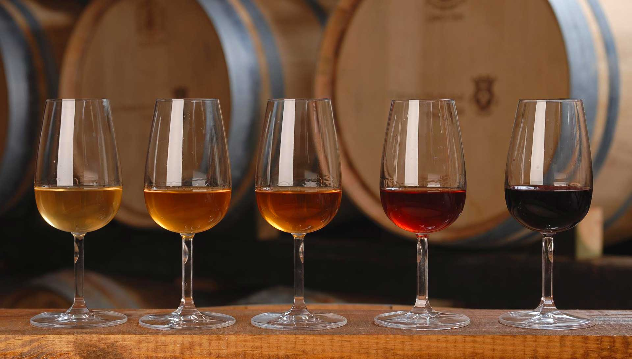

The Port wine cellars are located in Vila Nova de Gaia. From the Ribeira of the city of Porto, crosses the D. Luís I bridge and immediately finds the different cellars and wine brands of Porto.
We recommend all guests to visit the city, to visit at least one port wine cellar, knowing the history and recognizing the quality of Port wine.
Curiously, almost all Port wine cellars have English names or surnames:
After a war against France, the English remained without any kind of import of wines. Thus, in the century. In the eighteenth century, they learned about the wines from the Alto Douro area and experimented with their blend with brandy and Brandy (so that they could be better preserved during their transport to England). In this way, they '' invented '' Port Wine.
After the creation of the Real Companhia Velha house in 1781, the Portuguese also began to enter into the Port wine business.

What caves to visit?
There are several Port Wine cellars to choose from and all of them with a high level of quality. We highlight:
Burmester - After passing the D. Luís bridge, it is the first basement found in Vila Nova de Gaia.
Sandeman - Known for its student logo with cover.
Ramos Pinto - It is situated in front of the river, also containing a small museum of wine-making objects.
Real Companhia Velha - The first Portuguese wine house in Porto.
Offley - One of the oldest British companies.
Ferreira - It is one of the more distant ones, but it is worth it due to the fact that it is inserted in an old convent. Worth it.

Schedules:
Monday to Sunday - 10am to 7pm
Prices:
Between € 5 and € 15 with guide and wine tasting
Address:
Avenida Diogo Leite (Vila Nova de Gaia)

