Oporto Transports
Although it is possible to walk to all areas of the city centre, there are also various types of public transport, especially if you want to move to other parts of the city. All transports are interconnected and can often use the same ticket / card for various means of transport.
If you want to use the public transport of the city of Porto, we advise that you choose to use the Andante card.
How does the Andante card work?
The '' Andante '' card is a rechargeable card, being able to change lines and transport (bus, metro, electric and even train) for one hour. It is important to validate your "Andante" whenever you change lines or transport.
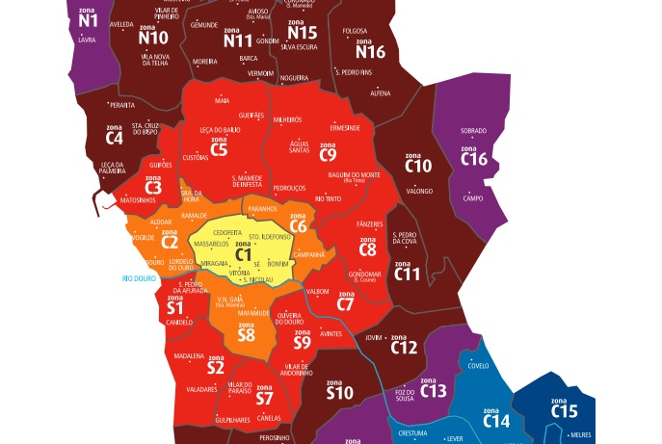

As you can see in the previous image, the different zones of the city of Porto are divided by the letter '' C '' (C1, C2, C3, etc.), however, to travel you must take into account the letter '' Z ‘’ (Z1, Z2, Z3, etc.) which represents the number of zones to be frequented.

Example:
If you are in zone C1 and you want to go to zone C6, you will need to purchase a Z2 trip, since you are in two zones.
If you are in zone C1 and choose to go to zone C8 or S7, you will need to purchase a trip Z3 because it crosses three zones.
If you start your trip in zone C1 and have destination to zone C12 or N11, you must purchase a trip Z4, as it crosses 4 different zones.
That is, it all depends on the zone you start and how many zones you go to. This map is at all bus stops and metro stations for your inquiry.
Prices per trip:
- Z2 = 1,20€
- Z3 = 1,60€
- Z4 = 2€
- Z5 = 2,40€
- Z6 = 2,80€

The Andante card is rechargeable, being used to travel in all public transport networks of the city of Oporto, including the metro, the buses and the funicular.
This card is personal and not transferable and can only be used by one person at a time. Children up to 4 years old can travel for free, without the need to purchase a card.
There is also a more focused card for the tourist, being able to be used for periods of 24 and 72 hours, being accessible to all points of the city. The time starts to be discounted from the first time it is validated. At the end of the period it is no longer possible to use, it is not rechargeable like the normal “andante card”. This card is called “Andante Tour”.
It can be bought at metro or train stations, inside buses and in tourist offices.
Prices:
- Andante Tour 1 (24 hours) = 7,00€
- Andante Tour 2 (72 hours) = 15,00€

Bus
The city's public bus service covers almost the entire area of Oporto and is represented by the company STCP. If you do not have a metro station near your apartment or the destination you choose, this will be an excellent option.
The unit price of a trip is 1.95 €, if purchased directly to the driver inside the bus. However, you may also choose to use the "Andante" card.

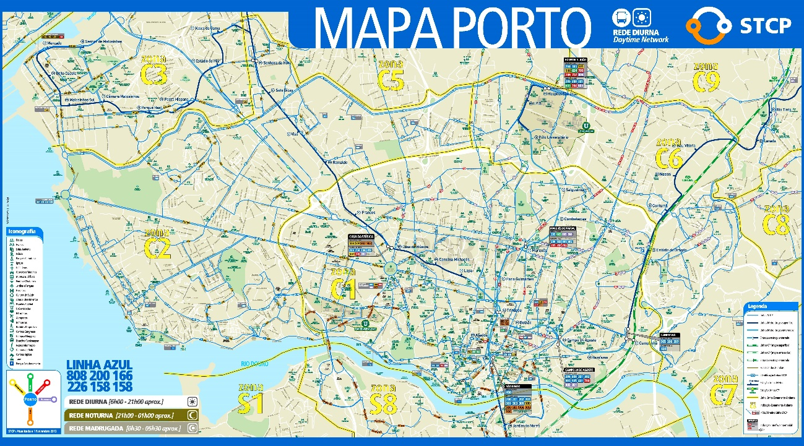

In addition to the city buses connecting the different points of the city, you can also go to other cities in the country.
You will have to go to the central bus station located in Campo 24 de Agosto. From there buses depart to cities like Aveiro, Coimbra, Lisbon and Algarve.

Metro
The Porto metro currently has 6 lines, covering a total of 60Km of the most important and distant areas, with a total of 70 stations.
Most of the subway lines are on the surface, giving travellers the opportunity to enjoy the sights of the city.
With regard to mobility, the metro offers more than 40 lifts for wheelchair users with reduced mobility.

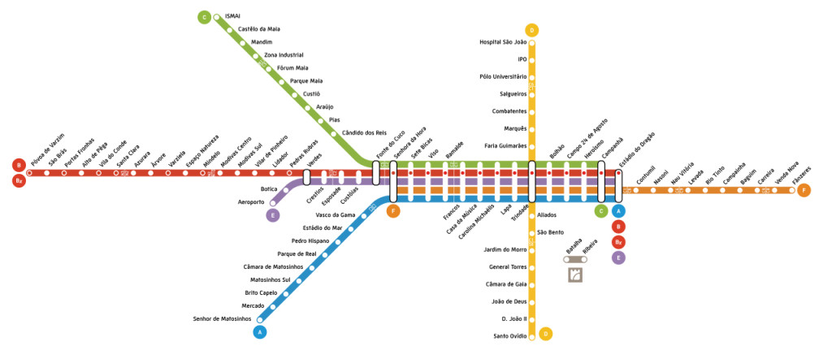
Underground lines:

The metro starts at 06:00 in the morning and closes at 01:00 in the morning. The frequency of meters passes every 5/10 minutes. In some lines, less used the frequency of passage can be between 15/20 minutes.
The frequency of the airport metro station is 30 minutes.

Cable Car
On the banks of the Douro river, linking the upper zone of the D. Luís I bridge, and the Port wine cellars is the Gaia Cable Car.
From the upper part of the bridge, you can admire the route of the river that runs towards the sea, the D. Luís I bridge itself, the D'Arrábida bridge and the beautiful Ribeira do Porto.
The trip lasts 5 minutes and has a maximum capacity of 8 people per cabin.

Prices:
- Adult Ticket: 6€ One way / 9€ Round trip
- Kids Ticket (from 3 years old): 3€ One way / 4,50€ Round trip
