Oporto Monuments

Invicta City, of austere and simple beauty, the Port begins to dazzle the world and to enchant more and more tourists who visit the capital in the North of Portugal. In the last years the prizes happen. The city is more beautiful, many of the buildings have been recovered or are in recovery and tourists arrive in large numbers.
It all started in 1996, when the historic center of the city of Oporto was considered a World Heritage Site by UNESCO. We could point out several reasons for the attribution of this recognition, but one thing we are certain: It is the urban landscape, drawn by the contours of the Porto house, its monuments built in centuries past and the knowledge to conjugate the old, with the contemporary, that make the Porto is a unique city to the world.

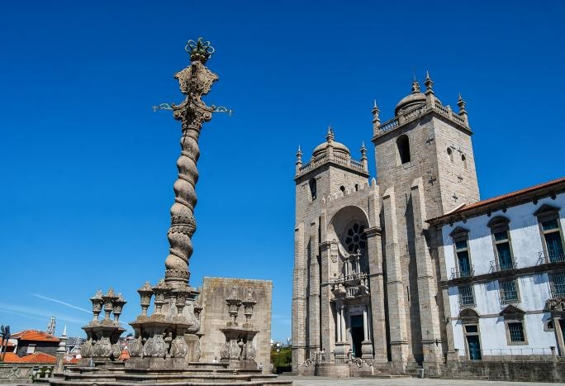
Oporto Sé Cathedral

The Cathedral of Porto (or Oporto Cathedral) is one of the main monuments of the city, including national monument and episcopal seat of Portugal.
It is located in the historical center of the city and in the upper part of the Bairro da Sé, one of the main districts of the city of Porto.

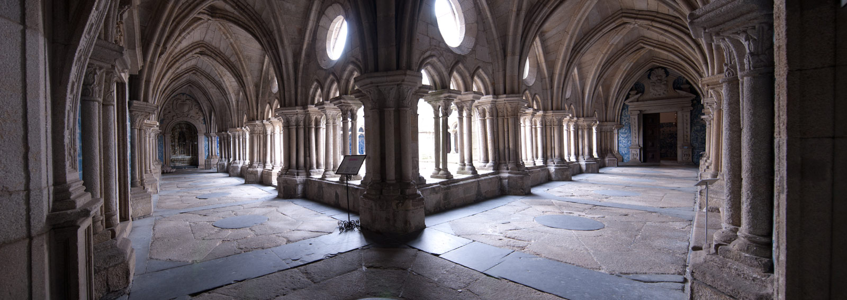
Its construction began in the first half of the century. XII and finished at the beginning of the century. XIII.
Initially Roman architecture, it underwent numerous changes over time, and the Gothic style was added through a funerary chapel, during the reign of D. João I.
In 1736, also the Italian Nicolau Nasoni, added baroque details to the lateral facade of the Sé.
Finally in 1772 a new portal was constructed to replace the Roman original.
From the Cathedral you can go down to the neighbouring district: Bairro da Sé. It is one of the oldest and typical neighbourhoods of Porto, made up of old houses and labyrinthine streets that wind the city up to Ribeira.
Address:
Terreiro da Sé, 4050-573. Porto

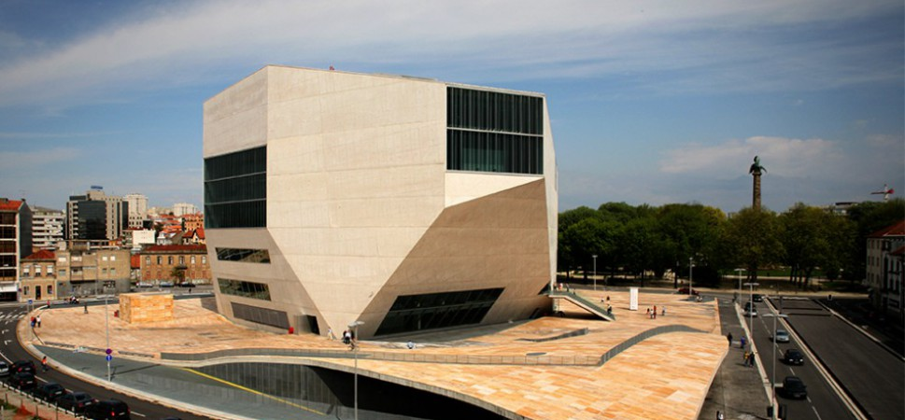
Casa da Música

Casa da Música is a cultural building where concerts and events take place throughout the year. Its contemporary design is due to an architect of Dutch origin (Rem
Joolhaas), which has countless architectural projects around the world, with CCTV headquarters in Beijing being one of the best-known works.
Its construction began in 1999 with the aim of coinciding with the year in which the city of Porto was elected European Capital of Culture (2001) but was only fully completed in 2005.
Today it is one of the icons of the city of Porto, both nationally and internationally.
The beauty of this building lies in its ability to adapt, as its main show room is suitable for multiple recreational and cultural activities.
In addition to its perfect acoustics, ideal for all types of concerts, also Casa da Música Restaurant, on the top floor, has capacity for 250 people and has an exceptional view over the city of Oporto. It also functions as a bar with outdoor terrace, where electronic music predominates.
During a full season, Casa da Música hosts classical music projects, electronic music projects, street music, among other theatrical performances.
Address:
Avenida da Boavista, 604-610

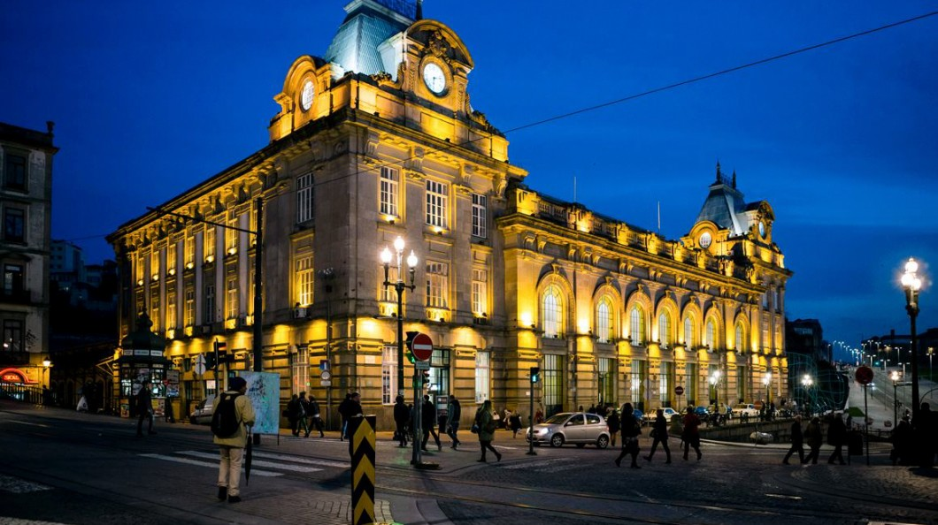
Estação de S. Bento

The São Bento station is considered the most beautiful train station in Portugal and one of the most beautiful in the world.
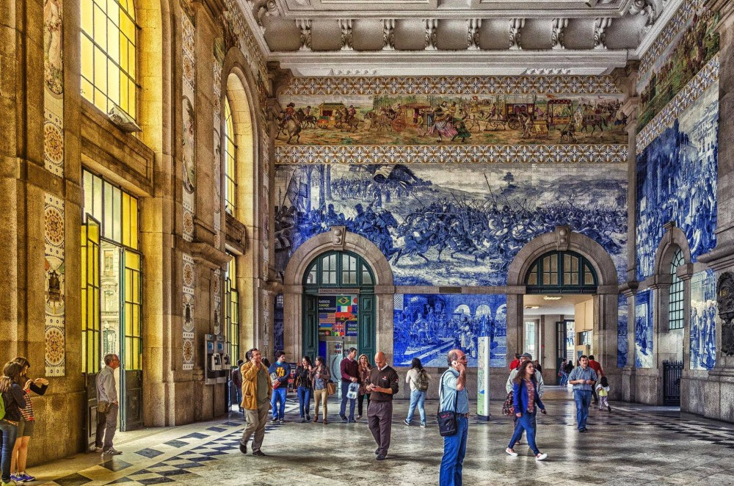
It is located a few meters from Avenida dos Aliados (in the center of the city) and although the train is not the way to get to the city, we strongly advise you to visit it to see its beautiful lobby.

The building was built in granite and inaugurated in 1916, and is an exceptional creation of the architect José Marques da Silva. On the other hand, the famous hand-painted tiles are the work of the artist Jorge Colaço.
Entering the main lobby of the São Bento station is an impressive wall with twenty thousand tiles, with important scenes of Portuguese history, such as the Battle of Valdevez, the conquest of Ceuta in 1415 or the visit of King Juan I to Port city.
To not lose!

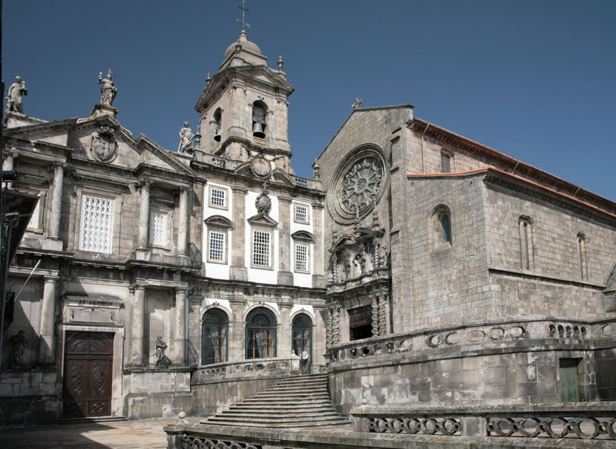
Igreja de S. Francisco
One of the most impressive architectural monuments of the city of Porto is the São Francisco Church, located in the center of the city, just behind the Palácio da Bolsa in Ribeira.
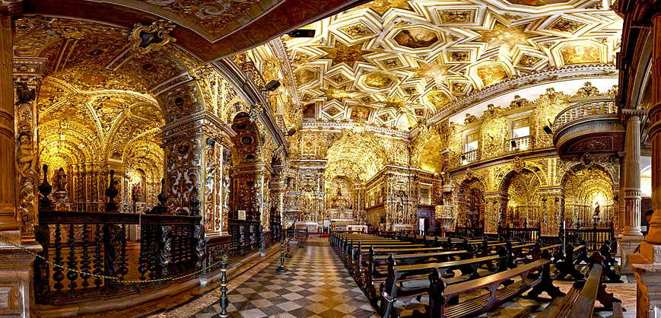
Its construction began in the 19th century. XIV by the Franciscans, undergoing some modifications throughout the centuries. Built essentially from Brazilian wood and gold, the most impressive is undoubtedly the baroque details inside, transporting the visitors for the time of the discoveries and colonization of Brazil.
For lovers of architecture and art, it is certainly a must-see site. Besides its own wealth inside the church, it also has a Gothic convent, catacombs and a small museum with church pieces.
Address:
Rua do Infante Dom Henrique
Schedules:
9am to 6pm

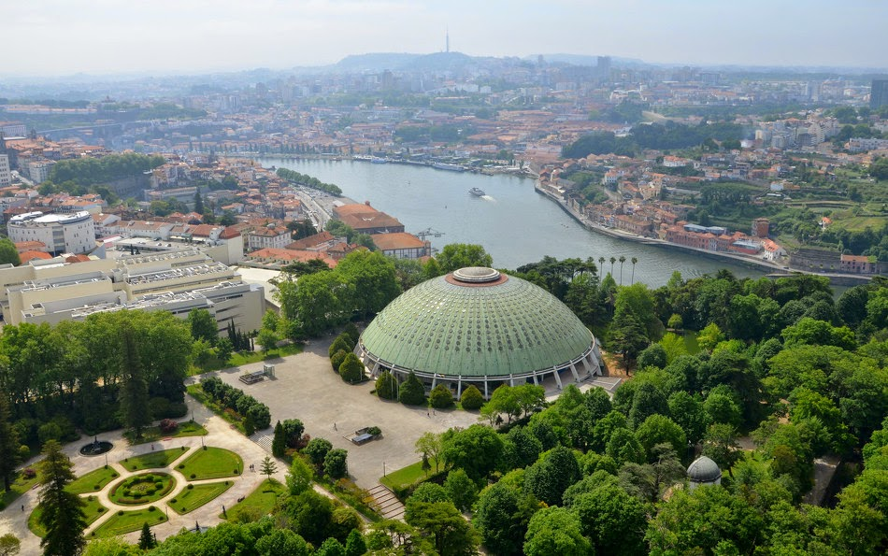
Palácio de Cristal

Very close to the center of the city is this precious botanical garden that bears this peculiar name: Palacio de Cristal.
There is currently no palace inside. The name refers to a palace that was built exactly in the same place in 1865 by the English architect Thomas Dillen Jones, in which it used like model the Crystal Palace of London. It was a place where the Oporto International Exhibition and other important exhibitions were held.

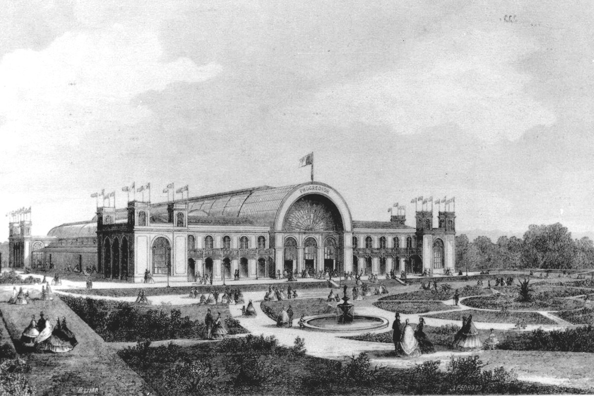
The original building was unfortunately replaced by the current '' Rosa Mota Pavilion '', being a space destined to host different fairs and exhibitions that are celebrated in the city. In fact, this pavilion is not so special, but the gardens that surround it and the view that one has from there, are highly recommended.
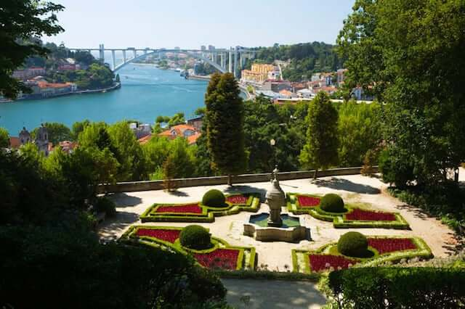
These beautiful gardens of romantic architecture, opened in 1860, are the perfect place to relax, picnic, stroll or observe various animal species that roam freely. It's a small zoo in the center of town.
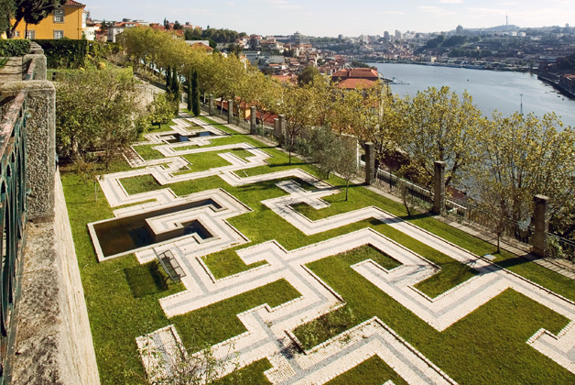
Around the pavilion there are gardens and spaces with various environments. Each garden has a name a theme, in which every season of the year seems to change.

Water is also an important element and the Crystal Palace Gardens include it in fountains, lakes and precious views of the river.
As we mentioned earlier, it is also a botanical garden, so all species have associated their name and country of origin. From these gardens we can see not only the river Douro and its bridges, but also the flow of this river into the Atlantic Ocean.
For a trip for two, or if you visit the city of Porto with your family, this is a must see.
Address:
Rua Dom Manuel II
Schedules:
October to March - 8am to 7pm
April to September - 8am to 9pm

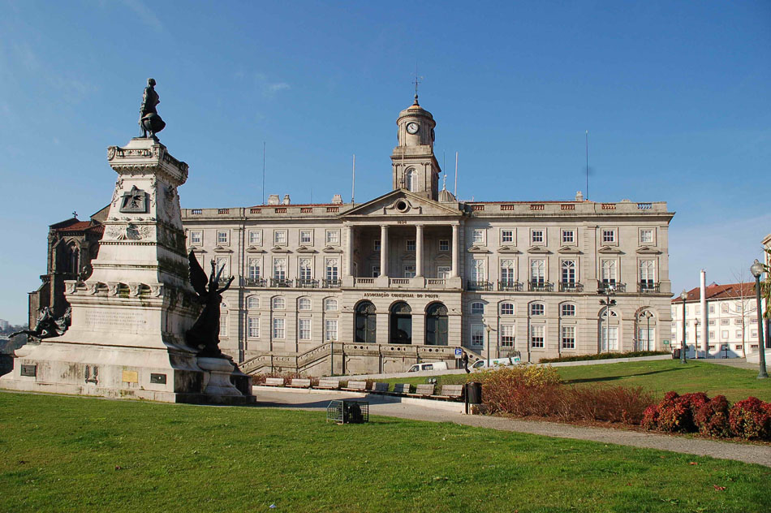
Palácio da Bolsa

Considered as a national monument, Palácio da Bolsa is one of the most visited sites in Porto.
Neoclassical architecture, the Palace of the Stock Exchange is the seat of the Association of Merchants of Porto, in which they requested its construction in 1842. The association ensured that its headquarters represented them in all its power, representing in some way the triumph (at the end of the eighteenth century) of the bourgeoisie, the merchants and the export of products that characterized so much this time and helped the city of Porto in economic terms.
Composed of different rooms, Palácio da Bolsa is famous for the Arabic Room that reminds you of the ancient city of Alhambra in Granada. Also, the Patio of Nations, the Presidential Hall and the General Assembly Hall are icons to be seen.
This palace is located next to the São Francisco Church, between the Baixa and Ribeira areas.
Address:
Rua de Ferreira Borges, 4050-253

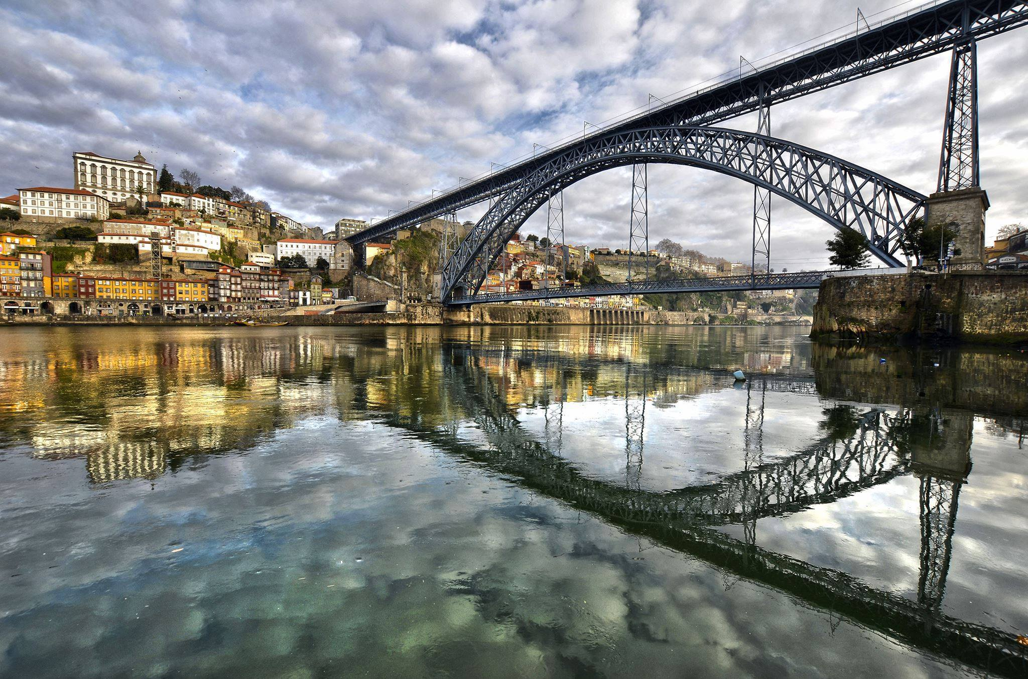
D. Luis I Bridge

It is from the Ribeira that it is observed in its maximum splendour the Dom Luíz I Bridge or D. Luís I Bridge, the most famous bridge in the city of Porto.
It was built in 1877 by Téofilo Seyrig, who was a partner of Gustavo Eiffel (yes, the same who built the famous Eiffel Tower) and that is why he is often confused by his authorship.
It is now possible to cross by foot on both levels of the bridge, however on the lower level it is also possible to cross by car. The upper level is intended for the metro and people.
In summer it is possible to observe the '' boys from Ribeira '' to throw themselves from the lower level to the river.
You should not leave the city of Porto, without a photo of the Dom Luíz I Bridge.

Torre dos Clérigos
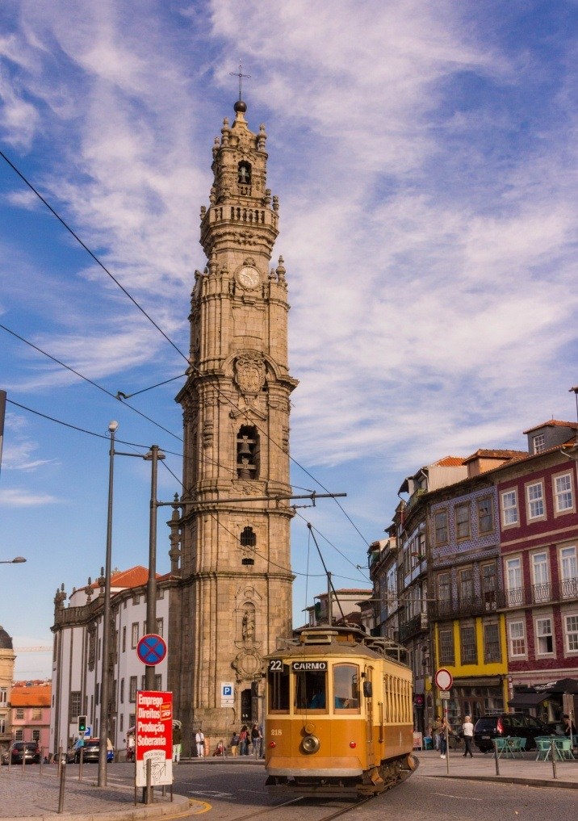
The visit to the Clérigos Tower and its church is one of the most important to do in the city of Porto.
The Clérigos Tower is a steeple built in granite and marble that is part of the Clérigos Church. It was designed by the architect Nicolau Nasoni and built between 1754 and 1763.
It was also used as a guide to get to the port of Ribeira, by the boats that arrived at the port of the city of Porto.
Its aerial view, 76 meters high, after 240 steps, is one of the attractions of the city. From the top it is possible to have an indescribable view.
It was the tallest tower in Portugal until the end of the last century (until losing its status to the Vasco da Gama Tower in Lisbon), however it must be considered that it was completed in 1763!

Prices:
Visit the church - Free.
Visit the tower - € 5
Address:
Rua Senhor Filipe de Nery
Schedules:
Every day from 09h to 23h

Bookstore Lello
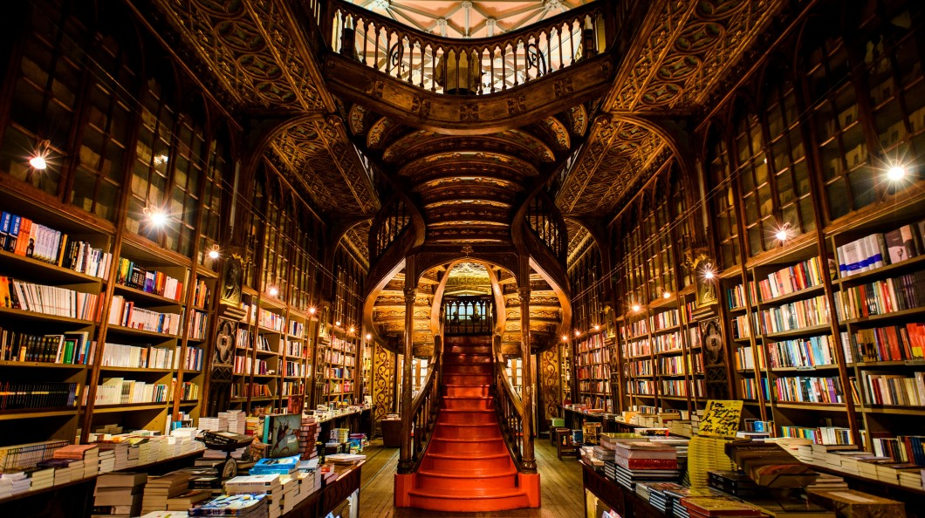
Lello Bookstore is world famous and has been chosen several times as one of the most beautiful bookstores in the world. When visiting Porto, do not miss it.
This beautiful building began to be built in 1904 and was inaugurated on January 13, 1906. The architect responsible for his work was the architect Xavier Esteves and painted by the artist José Bielman.
It is not only its façade that is beautiful. Its interior can surprise even more the people who visit: Its majestic staircase and all its construction in wood carved by hand, are undoubtedly the ex libris of this bookstore.
It is also known that the author of Harry Potter (J.K. Rowling) was inspired by this bookstore to write this phenomenon known worldwide. The author lived in Porto for a couple of years and, like many artists, fell in love with the bookstore and the city, leading her to write the Harry Potter saga in our city.
Currently, this bookstore has literature for all tastes, from the most elitist, to the most popular. Due to the high number of tourists it receives, they also have books in several languages.
Prices:
€ 5 you can cash in on buying a book.
Address:
Rua das Carmelitas 144
Schedule:
From Monday to Sunday - 10am to 8pm

